Report on results and details of Students Satisfaction Survey (SSS):

Course : B.Ed & M.Ed

Academic Year : 2015-2016

1. **How much of the syllabus was covered in the class?**

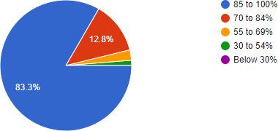

1. **How well did the teachers prepare for the classes?**

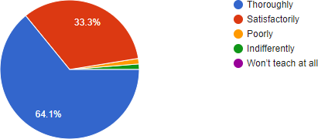

1. **How well were the teachers able to communicate?**

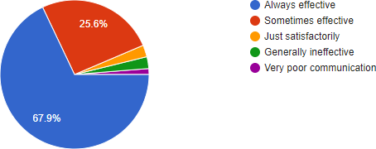

1. **The teacher’s approach to teaching can best be described as**

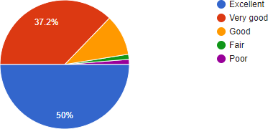

1. **Fairness of the internal evaluation process by the teachers.**

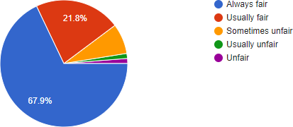

1. **Was your performance in assignments discussed with you?**

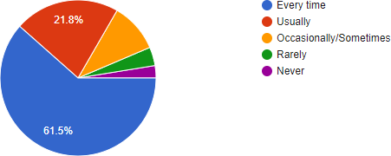

1. **The institute takes active interest in promoting internship, student exchange, field visit opportunities for students.**

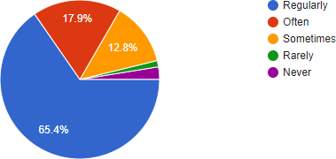

1. **The teaching and mentoring process in your institution facilitates you in cognitive, social and emotional growth.**

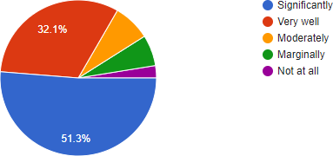

1. **The institution provides multiple opportunities to learn and grow.**

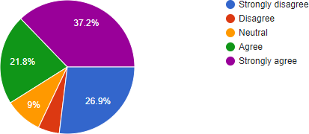

1. **Teachers inform you about your expected competencies, course outcomes and programme outcomes.**

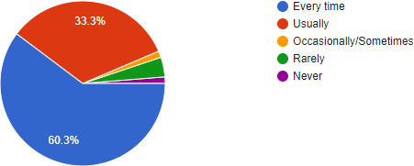

1. **Your mentor does a necessary follow-up with an assigned task to you**

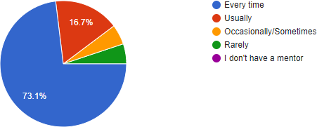

1. **The teachers illustrate the concepts through examples and applications.**

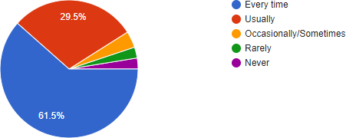

1. **The teachers identify your strengths and encourage you with providing right level of challenges.**

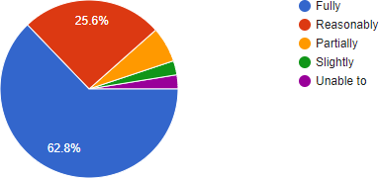

1. **Teachers are able to identify your weaknesses and help you to overcome them.**

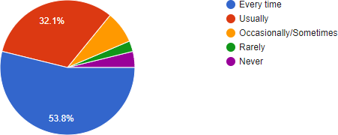

1. **The institution makes effort to engage students in the monitoring, review and continuous quality improvement of the teaching learning process.**

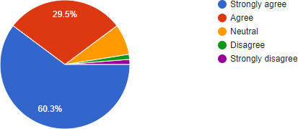

1. **The institute/ teachers use student centric methods, such as experiential learning, participative learning and problem solving methodologies for enhancing learning experiences.**

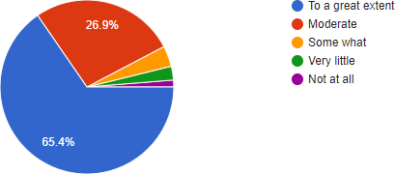

1. **Teachers encourage you to participate in extracurricular activities.**

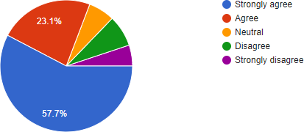

1. **Efforts are made by the institute/ teachers to inculcate soft skills, life skills and employability skills to make you ready for the world of work.**

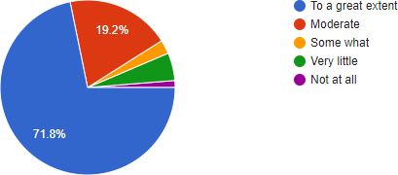

1. **What percentage of teachers use ICT tools such as LCD projector, Multimedia, etc. while teaching.**

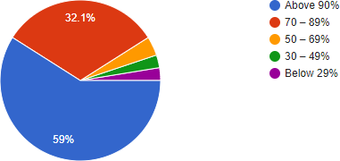

1. **The overall quality of teaching-learning process in your institute is very good**

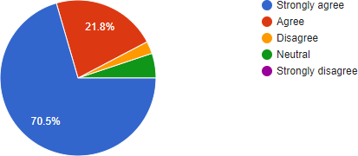

1. **Provide observation / suggestions to improve the overall teaching – learning experience in your institution.**

* Faculty are very much interested in explaining subject oriented examples, very very fair in correcting internals and externals
  + overall good teaching
  + We are fine with faculty with good suggestions
  + more interaction
  + Fine with faculty
  + In our college there is a very best thing which is called as wit and will programme. but i hope this programme is not going perfectly so, i hope make this should properly.
  + Our CLG as separate agenda that is WIT and WIL. Should give more practical learning
  + Excellent faculty
  + Excellent teaching Nice practical knowledge Overall best in all factors
* Attendance min percentage must be reduced to 60%. So that we will have more time to learn about the world. libary was good . i want more books in libaray .
  + the changes in teaching style and the learning are not required, everything is perfect.
* Students are given wit and will reports which are enhancing their knowledge by learning the applications.